Air traffic by the numbers only use pic 3 I combines it so pic 1 & 2 are duplicates so delete
Navigation latitude and longitude
Delete image 4 it is the blurry one I redid image 3 is the good one. Then delete the following text “Image 4 is the earlier version of the same lesson with yellow callout boxes. In both, longitude values increase going west and latitude values increase going north—do not treat the callout boxes as the latitude or longitude lines themselves.”
You will need to correct the image number for the text after that since there is no longer image 4.
Figure 5 is a practice so it should be after pic 6 & 7 when you are going through the latitude and longitude graphs
Delete pics 8 & 9 and the following text – “ images 8 and 9 of 9 are quiz figures—use them last to check that you can read coordinates without the teaching callouts. Image 8 is a Key West crop from the Miami sectional (use the 25° N and 82° W graticule labels); Image 9 is a Kentucky–Tennessee crop around Glasgow and Tompkinsville.”
Be sure to re-number the images as now there are only 6 images

Aeronautical charts – After this text “ Explain how aeronautical charts support remote pilot planning and how sectional and terminal area charts fit into the four airport data sources.” delete the pic as shown below.
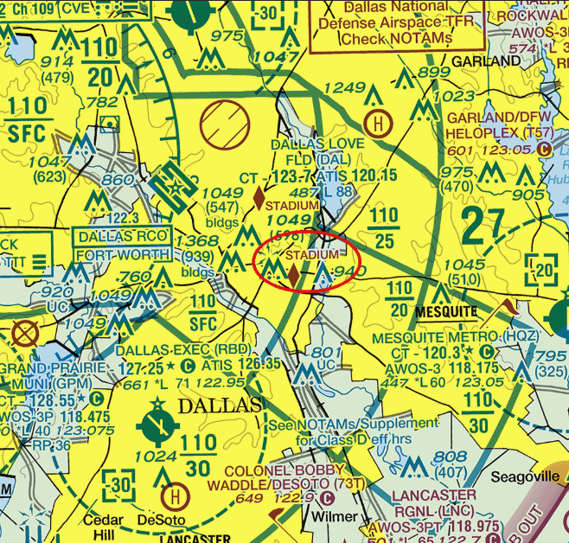

Sectional charts – pics in wrong order pic 3 should be pic 1, then New Orleans then Memphis Be sure to fix the text where it explains it so they are in order
Chart legend Supplement – image 5 of 8 should be pic 1 to make sense.

Class E
Image 3 should be 1st in that pack of pictures as well as the text that goes with it. Then the other 2 pics, fix the text so that those 2 pics will then refer to the correct image
Class E2 - Paulding Northwest Atlanta (PUJ) should be image 1 then move the text , Monrose Rgnl (MTJ) – should be image 2 as it is now, bethel should be image 3 then move the text,
Special use airspace – missing pic use special use airspace add text to say it is image 1
Looks like this 